Done By: Chris Kelley

Fahmida Jyoti

Souparni Agnihotri

**Project B Lab Report**

**Prelab:**

The list of required instructions:

|  |
| --- |
| J |
| Jal |
| Jr |
| Jalr |
| Mul |
| add |
| addu |
| Sub |
| subu |
| Addi |
| addiu |
| Or |
| ori |
| And |
| andi |
| Xor |
| xori |
| Nor |
| Slt |
| sltu |
| slti |
| sltiu |
| Beq |
| Bne |
| Bltz |
| Bgez |
| Bgezal |
| Bltzal |
| Blez |
| Bgtz |
| Lb |
| lbu |
| Lh |
| lhu |
| Lw |
| Lui |
| Sb |
| Sh |
| Sw |
| Sll |
| Srl |
| Sra |
| Sllv |
| Srlv |
| Srav |

Here is a link to our Control spreadsheet: [https://docs.google.com/spreadsheets/d/1rXrp06P24jf8koVl_dg353JkVGze0GONGRtWYkKqd5U/edit#gid=0](https://docs.google.com/spreadsheets/d/1rXrp06P24jf8koVl_dg353JkVGze0GONGRtWYkKqd5U/edit" \l "gid=0)

Below : We could give you a picture but it would not be clear. Instead we have a wave do file that shows our control logic test bench. controlWave.do

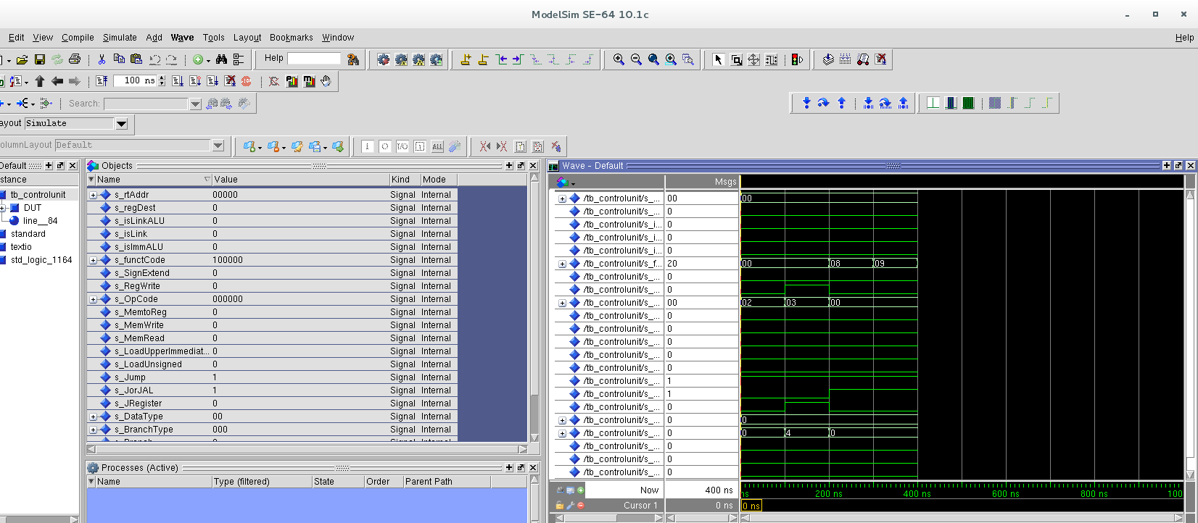

Our single cycle MIPS processor schematic

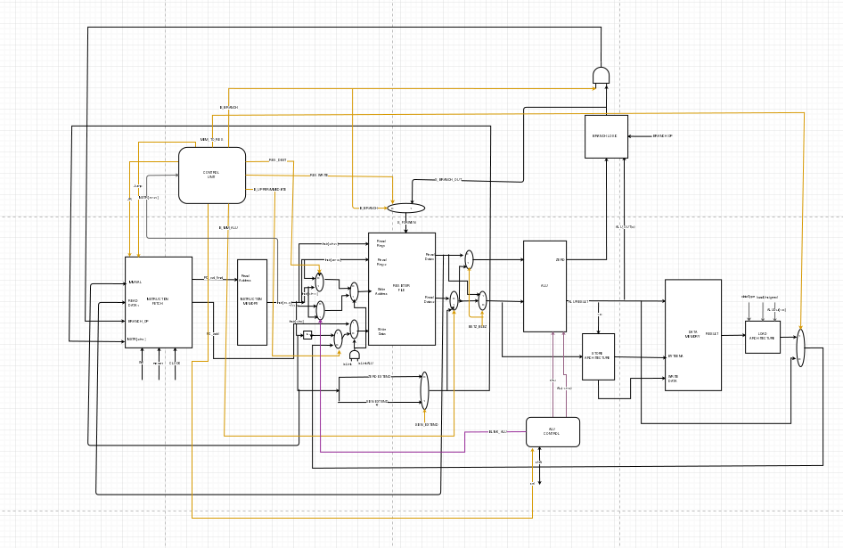

Link to the Mips processor schematic:

[https://www.draw.io/?state={%22ids%22:[%220BwKnxa5Y9DOEUEZkcUdLRmZjRFU%22],%22action%22:%22open%22,%22userId%22:%22112421586840883182988%22}#G0BwKnxa5Y9DOEUEZkcUdLRmZjRFU](https://www.draw.io/?state={"ids":["0BwKnxa5Y9DOEUEZkcUdLRmZjRFU"],"action":"open","userId":"112421586840883182988"}" \l "G0BwKnxa5Y9DOEUEZkcUdLRmZjRFU)

**1-bit ALU:**

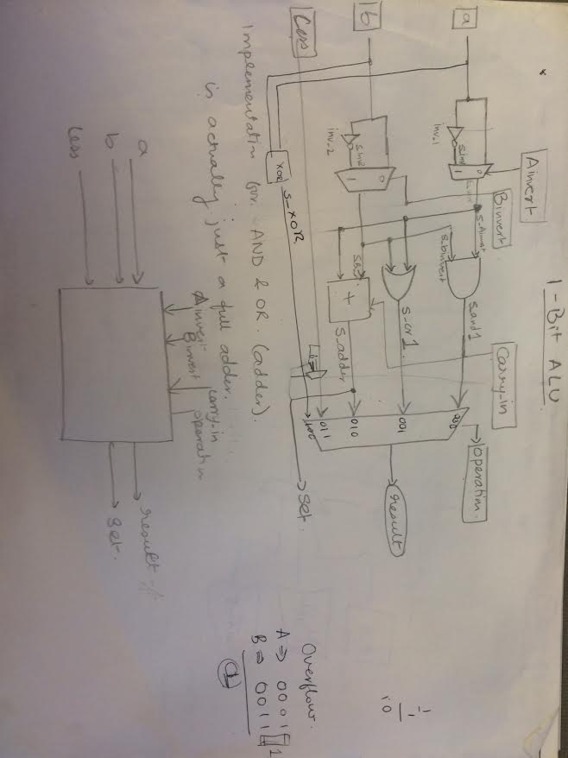

**Branch Logic:**

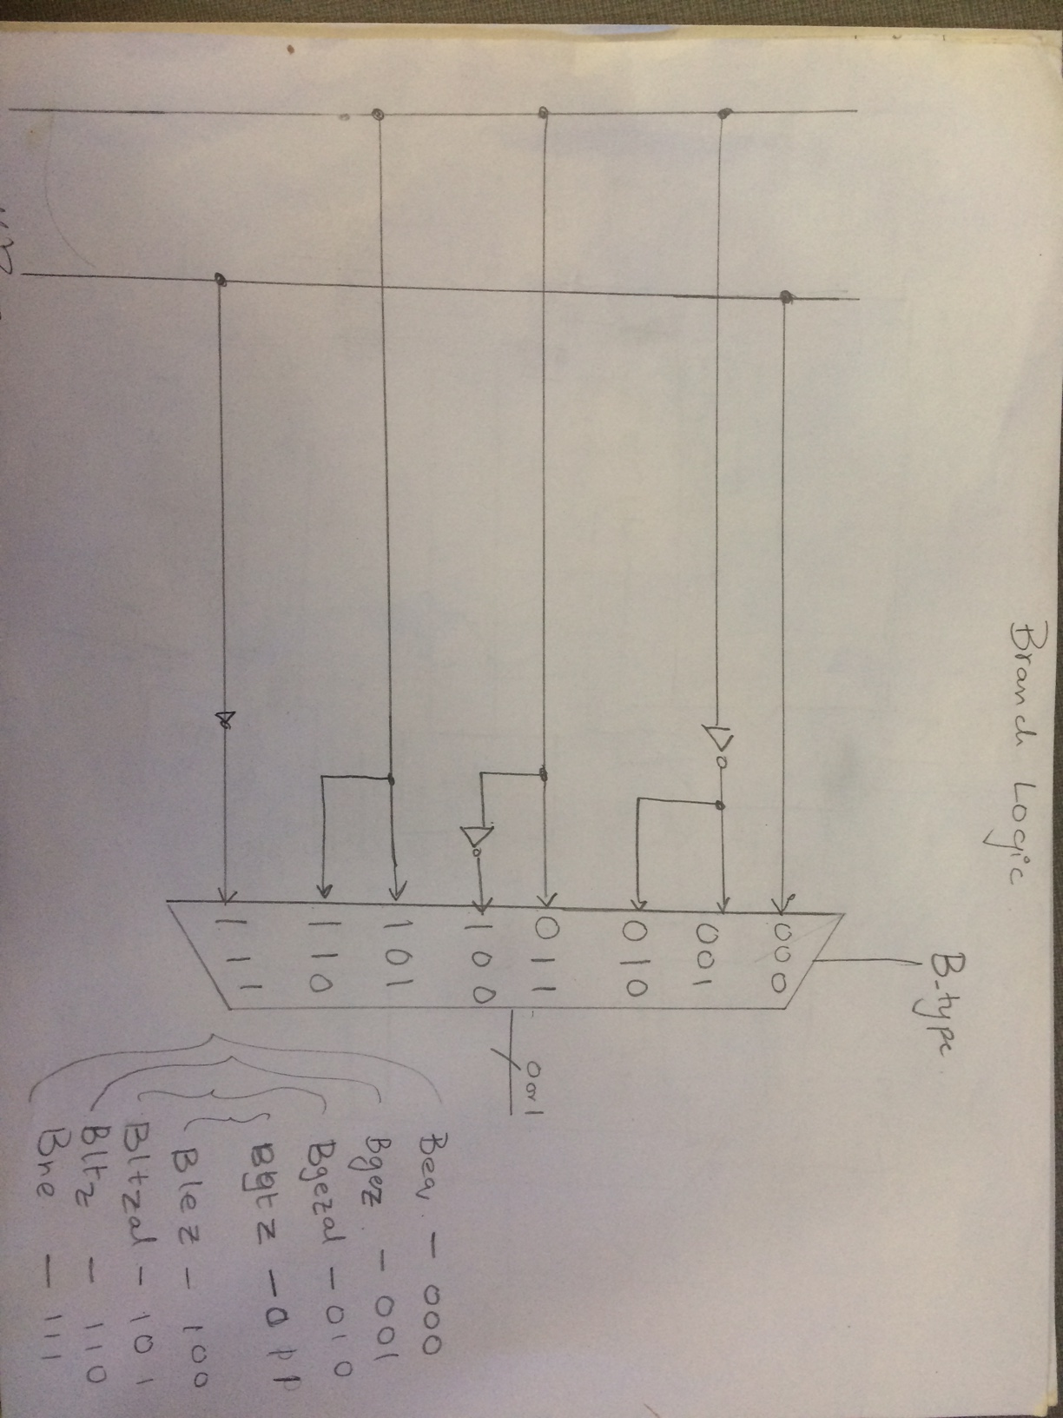

**ALU Main Unit:**

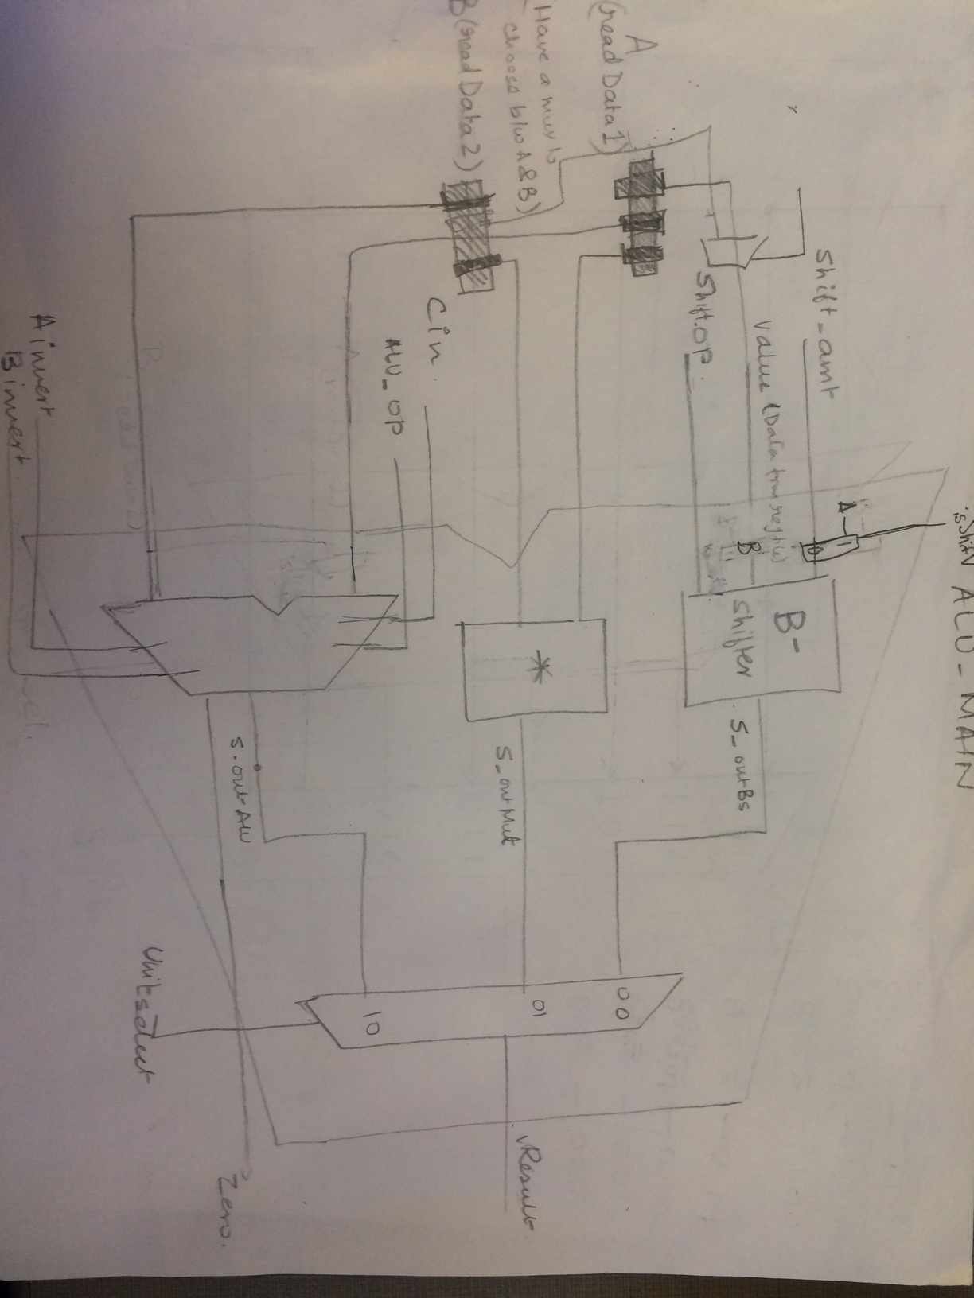

**Data Memory:**

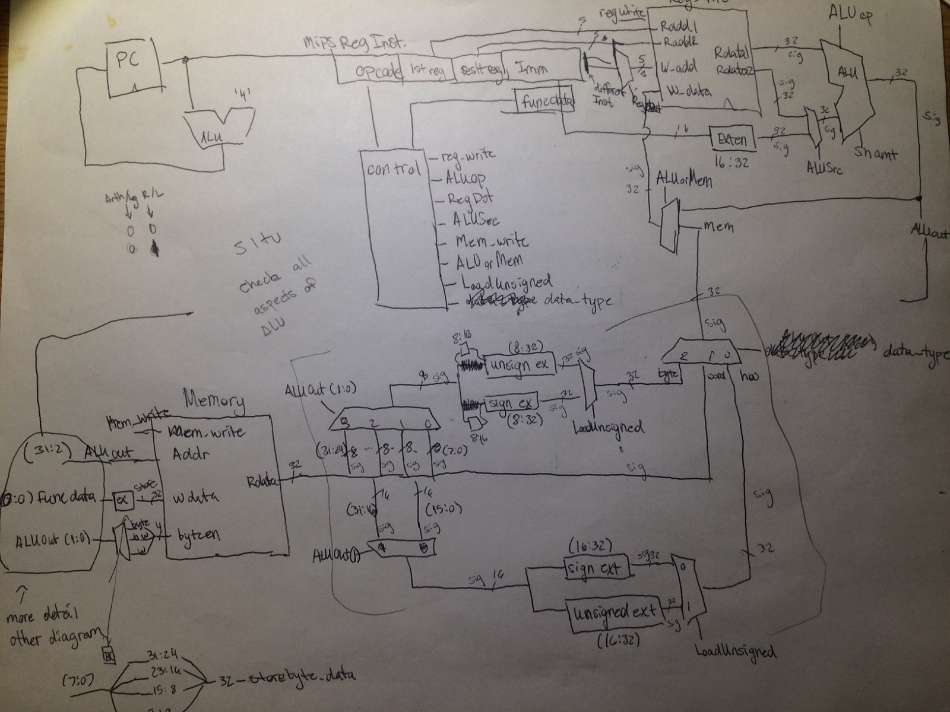

Here is a link to all the schematics that we made. It includes our load/store unit, our branch architecture, our 1-bit and n-bit ALU’s

<https://docs.google.com/document/d/1ROstgcWBxdg0RXZ4ayupjelbWWah8ZM3DalvIISI1JA/edit>

**Instruction Fetch Logic:**

The Instruction Fetch logic supports all our Jumps and Branch instructions. It also increments the program counter and makes sure that we move on to the next instruction. This is then loaded into our memory which determines the address of that instructions.

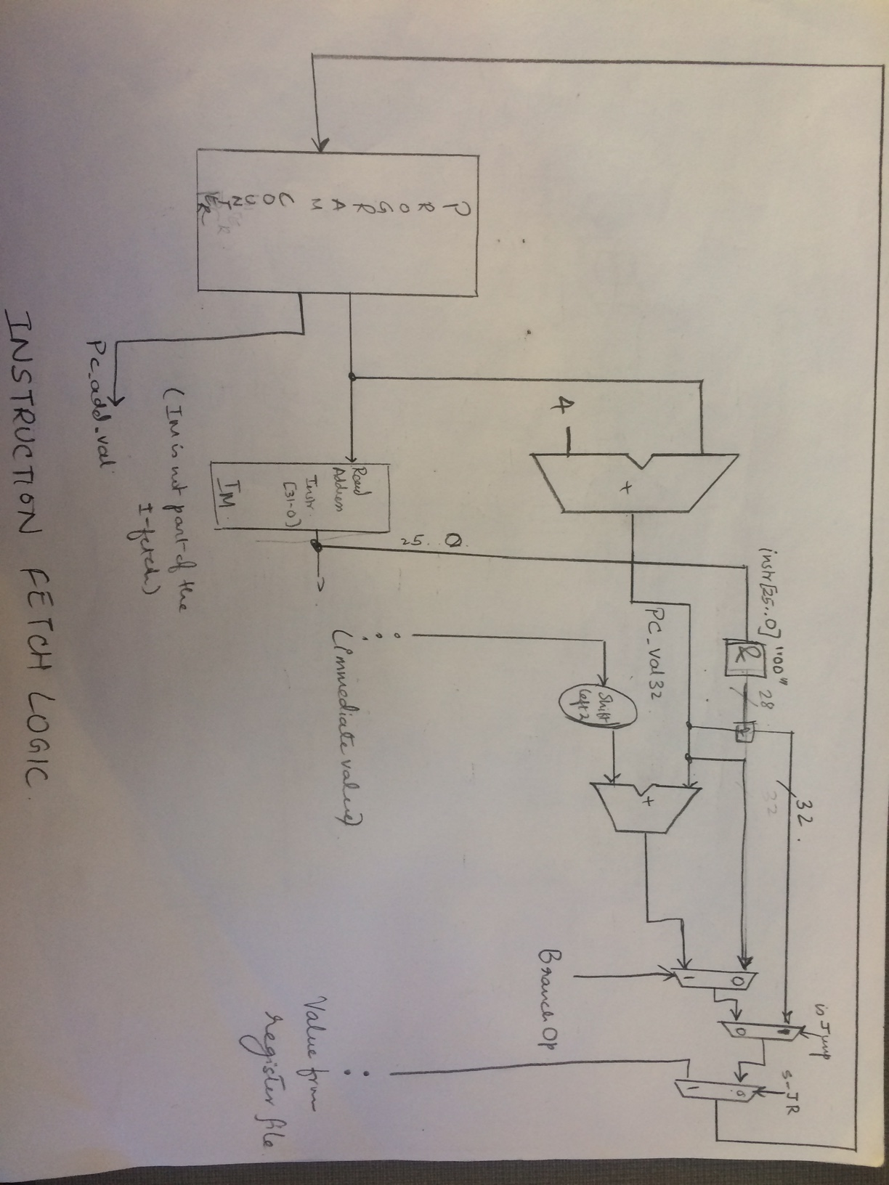

The different controls used and what they do:

1. BranchOp : This is the signal that comes from the Branch logic and determines if the instruction is a branch. If the value of this operation is a 1 then it will branch to the required destination. Otherwise it will move on to the next instruction.
2. isJump: This is the control that determines if the instruction is a Jump. Jump instructions (Jal, Jump etc) are moved to that particular address when this value is 0. (The offset value is chosen which is the 25 downto 0 bits from the instruction address)
3. JR: This is the signal that determines the value of the register location to jump to when a JR instruction is given. The read address1 output of the register file is the location it will jump to. If the value of this signal is 1, then it will jump to that particular register.
4. We would attach a photo of our instruction fetch but again the picture but is unclear. We have attached a do file of the instructionWave.do to be more clear.

Each cycle moves through a new instruction. We are able to look at our control flow logic and predict what each instruction requires. In this way we can see that the signals are in fact correct in each wave (despite the multiple ifetch iterations).

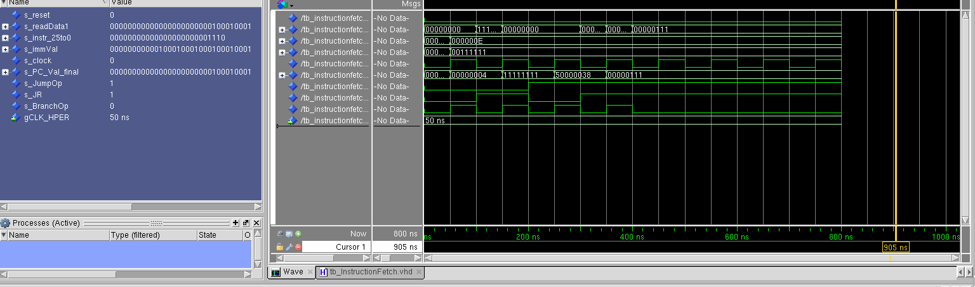

***Testing and implementation:***

**Instruction:**

**1. addi $t0, $zero, 5**  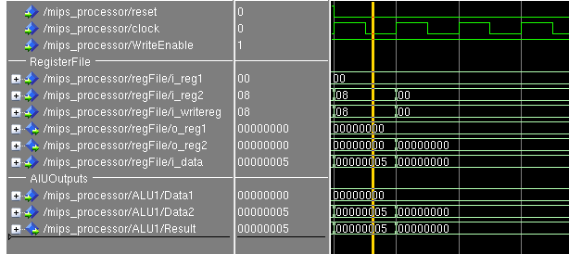

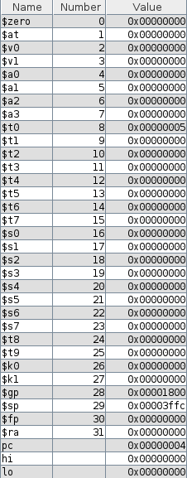

2. **ADD:**

addi $t0, $zero, 5

addi $t1, $zero, 6

add $t3, $t0, $t1

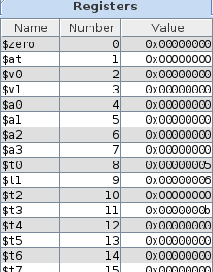

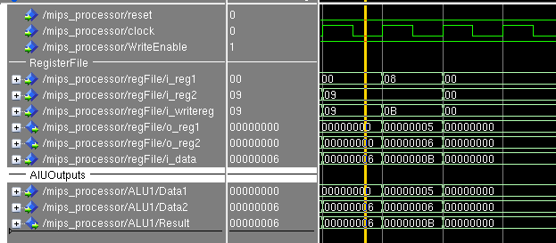

**3. ADDU:**

addi $t0, $zero, 5

addi $t1, $zero, -6

addu $t3, $t0, $t1

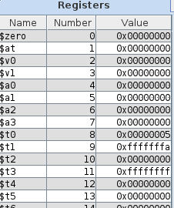

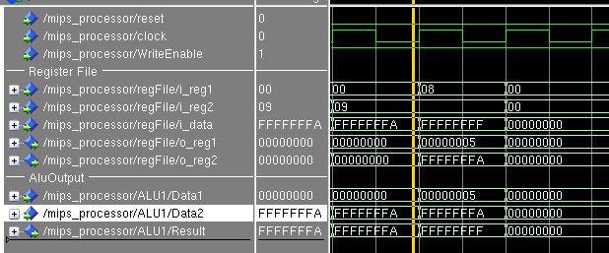

**4. SUB**

addi $t0, $zero, 5

addi $t1, $zero, -6

sub $t3, $t1, $t0

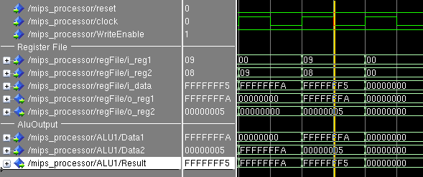

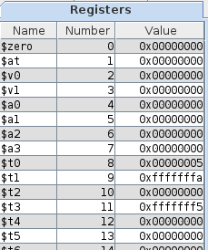

**5. SUBU**

addi $t0, $zero, -5

addi $t1, $zero, -6

subu $t3, $t1, $t0

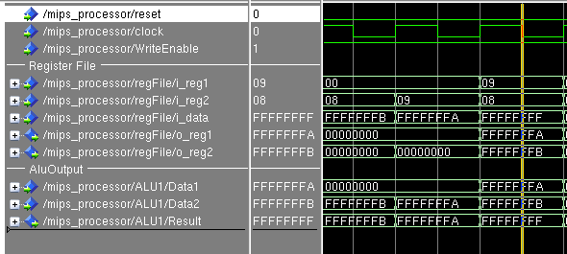

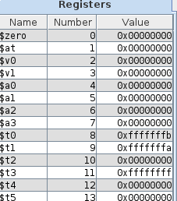

**6. ADDIU**

addi $t1, $t5,6

addiu $t2, $t1,-200

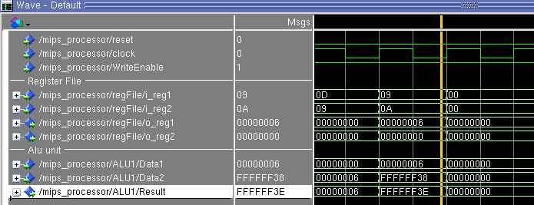

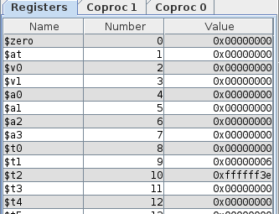

**7. OR**

addi $t1, $t5,1

addi $t2, $zero, 0

or $t3, $t2, $t1

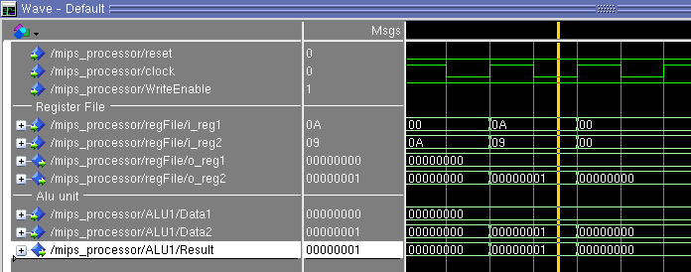

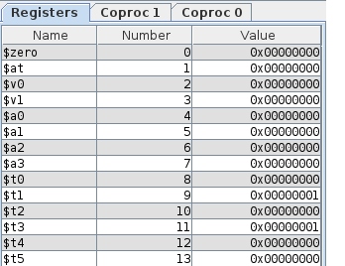

**8. Ori**

addi $t1, $t5,4

ori $t3, $t1,100

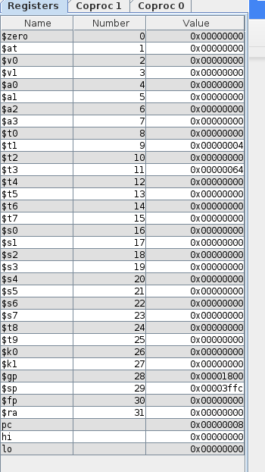

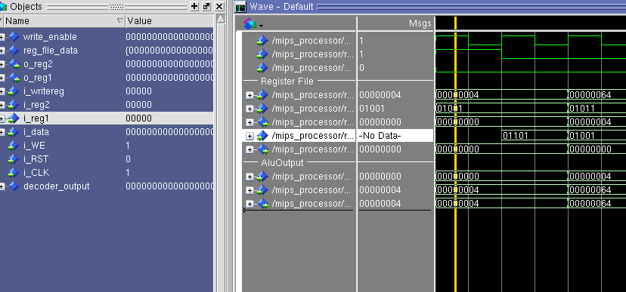

**9.And**

addi $t1, $zero,7

addi $t2, $zero ,12

and $t3, $t1,$t2

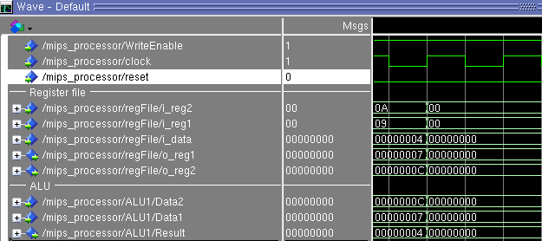

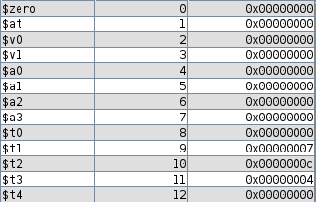

**10. ANDI**

addi $t1, $zero,7

addi $t2, $zero ,12

andi $t3, $t2, 100

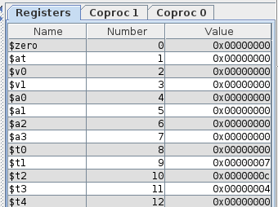

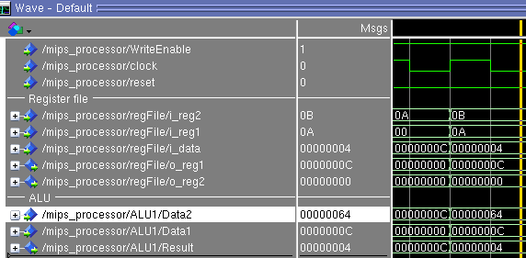

**11. XOR**

addi $t1, $zero,7

addi $t2, $zero ,12

xor $t3, $t2, $t1

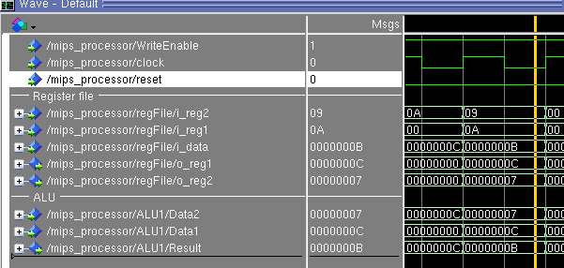

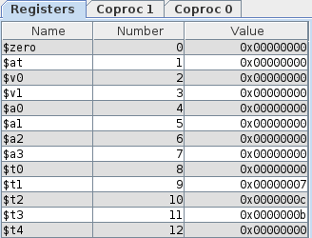

**12. XORI**

addi $t1, $zero,7

addi $t2, $zero ,12

xori $t3, $t2, 100

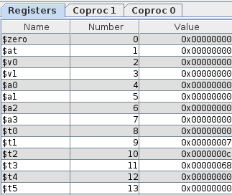

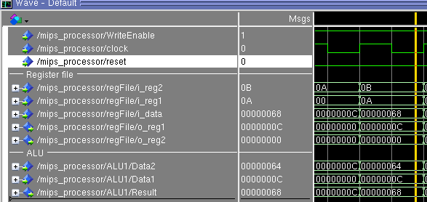

**13. NOR**

addi $t1, $zero,7

addi $t2, $zero ,12

nor $t3, $t2, $t1

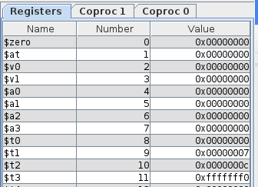

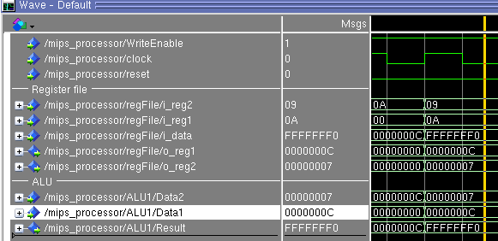

**14. SLT**

addi $t1, $zero,7

addi $t2, $zero ,12

slt $t3, $t1, $t2

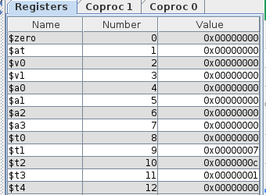

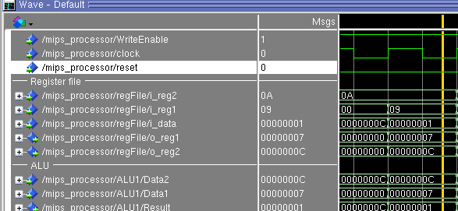

**15.Sltu**

addi $t1, $zero,7

addi $t2, $zero ,12

sltu $t3,$t2,$t1

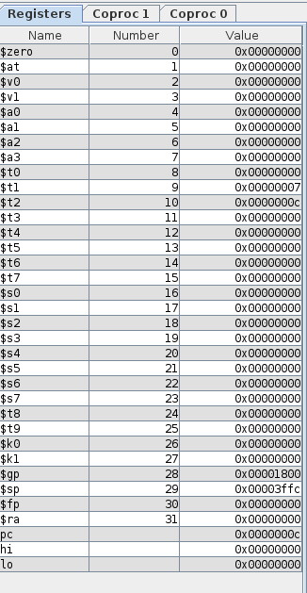

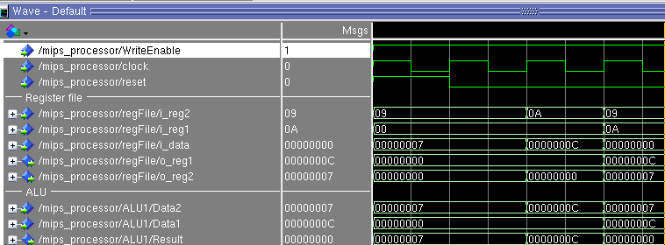

**16.Slti**

addi $t1, $zero,7

addi $t2, $zero ,12

slti $t3,$t2,-100

slti $t4, $t2,100

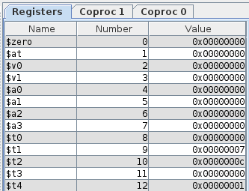

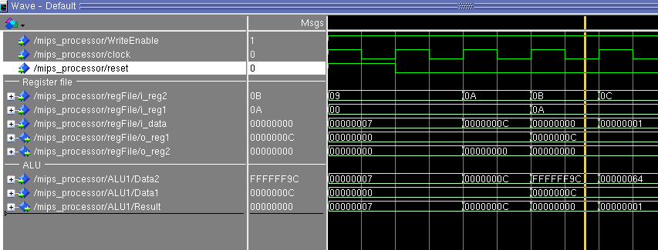

**17 Sltiu**

addi $t1, $zero,7

addi $t2, $zero ,12

sltiu $t3, $t2,-30

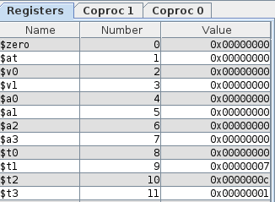

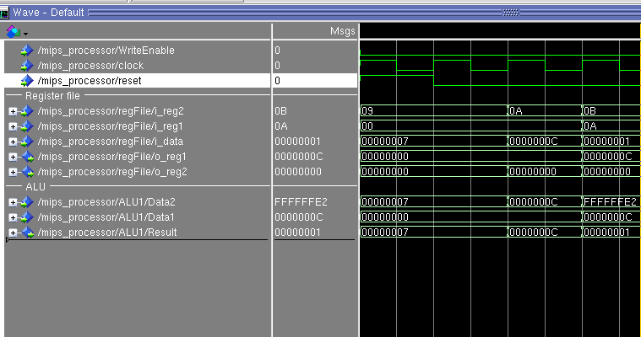

**18. Lui**

lui $t2,100

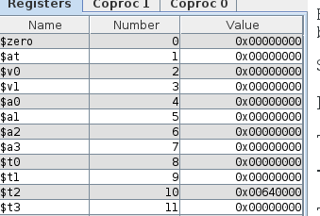

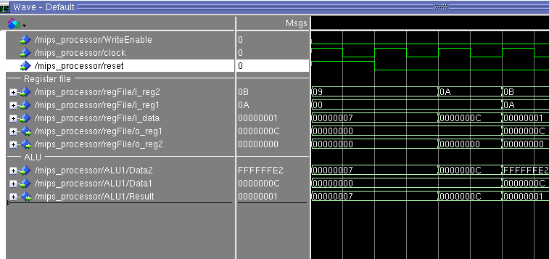

**19.Sll**

addi $t2,$zero,5

sll $t1,$t2,10

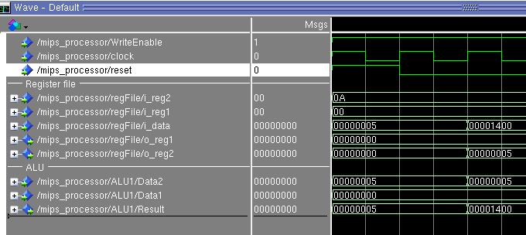

**Implementation Issues**

1. Issues with Instruction Fetch: We discovered that our instructions were jumping from 0 to 4 and back to 0. It took a long time for us to understand why this was happening and we discovered that it was because our n-bit full adder which we had implemented in dataflow was broken. This was one of our biggest problems.
2. Another thing we struggled with was the load instruction which wasn’t writing back to the register file. So we had a great deal of difficulty testing our load and store instructions.
3. We discovered our load architecture was in the wrong place.
4. We were also able to add in several new control signals and implement new logic due to the difficulties we ran into.
5. Branch and jump instructions would calculate correct control signals but would not find the correct next address instead resetting to zero.
6. Overall we understand what each instruction requires from our processor but ran out of time to test as much as we would have liked.

**Testing**

**List of 45:**

**The 45 instructions(final result after running all 45 instructions):**

The register destinations:

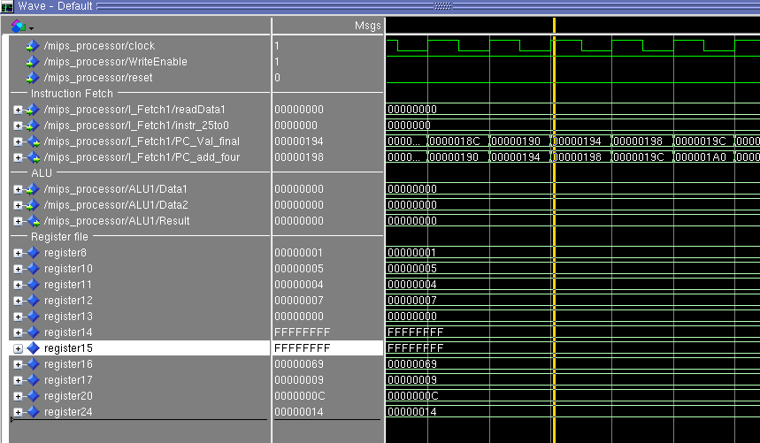

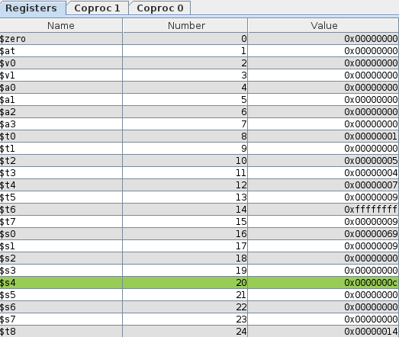

**Bubble Sort:**

Mars registers of final sorted array.

The array 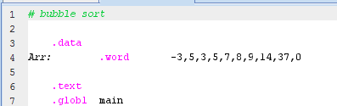

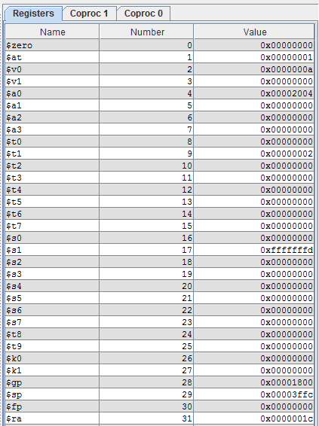

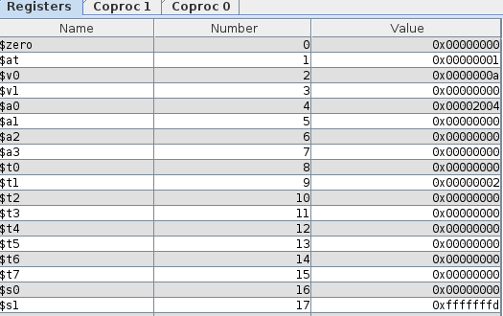

The memory

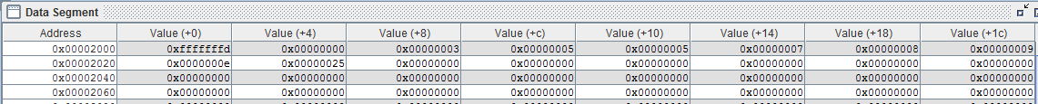

Our waveform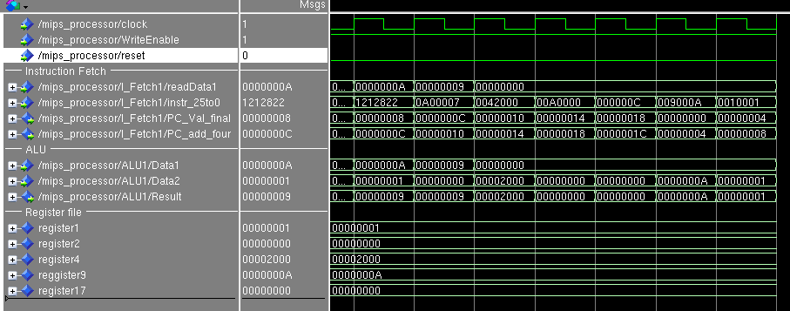

Our sorting did not work correctly as our jump instructions were not working correctly

**Merge Sort:**

Mars Register Outputs

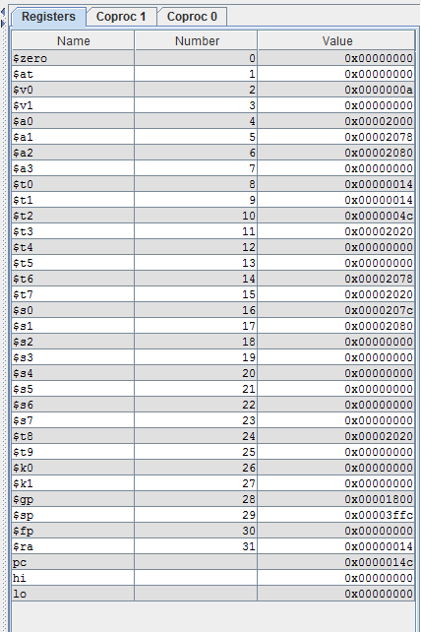

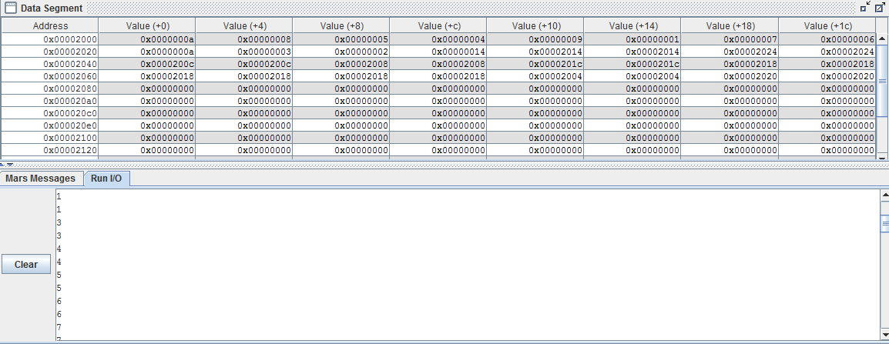

Vhdl waveform

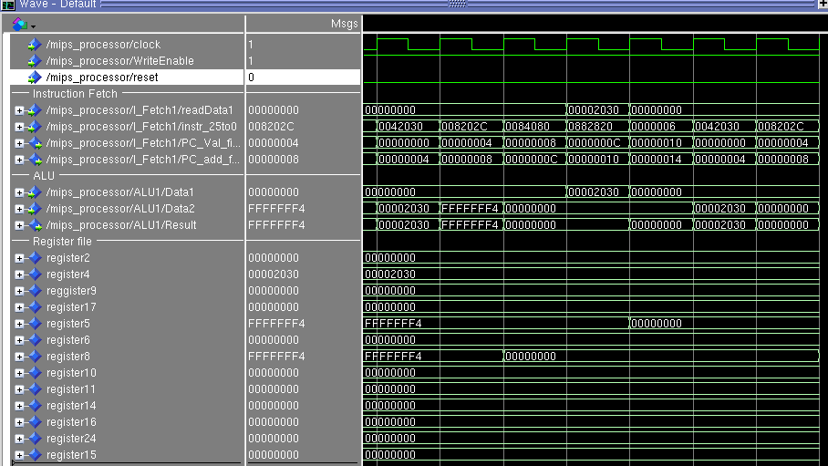

All the merge sort, bubble sort and 45 instructions assembly programs are attached with the submission in the zip file.